

C
olumbia Borough Fire Department

726

Manor Street

P O Box 426

Columbia
,

PA 17512
-
0426

MONTHLY
FIRE CHIEF’s REPORT

April 2025

Incident response statistics and additional Fire Department Activities for the month of 2025 along with Year-to-Date information.

Kevin A. Keyser, Fire Chief

Information released by the CBFD for informational purposes to the Columbia Borough Manager, Columbia Council and Columbia School Board members on
May 5, 2025.

INCIDENT RESPONSE STATISTICS (TOTALS):

YTD 2025 Totals
Incident Type * |  | January | February | March | April | May | June | July | August | September | October | November | December |  | 2024 Totals  2023 Totals | 2022 Totals | 2021 Totals
100 |  | 11 | 12 | 14 | 7 |  |  |  |  |  |  |  |  | 44 | 114 | 110 | 130 | 144
200 |  | 0 | 0 | 0 | 0 |  |  |  |  |  |  |  |  | 0 | 1 | 3 | 6 | 21
300 |  | 12 | 7 | 10 | 8 |  |  |  |  |  |  |  |  | 37 | 174 | 186 | 188 | 196
400 |  | 9 | 6 | 2 | 5 |  |  |  |  |  |  |  |  | 22 | 45 | 73 | 57 | 58
500 |  | 15 | 12 | 12 | 12 |  |  |  |  |  |  |  |  | 51 | 139 | 129 | 171 | 152
600 |  | 24 | 20 | 16 | 10 |  |  |  |  |  |  |  |  | 70 | 118 | 105 | 93 | 46
700 |  | 10 | 6 | 6 | 7 |  |  |  |  |  |  |  |  | 29 | 127 | 125 | 121 | 106
800 |  | 0 | 0 | 1 | 0 |  |  |  |  |  |  |  |  | 1 | 1 | 5 | 1 | 1
900 |  | 1 | 0 | 0 | 1 |  |  |  |  |  |  |  |  | 2 | 11 | 9 | 13 | 2
Totals: |  | 82 | 63 | 61 | 50 | 0 | 0 | 0 | 0 | 0 | 0 | 0 | 0 | 256 | 730 | 745 | 780 | 726
2024 |  | 61 | 58 | 58 | 61 | 57 | 68 | 60 | 70 | 59 | 68 | 57 | 53
2023 |  | 54 | 63 | 44 | 70 | 59 | 49 | 70 | 66 | 76 | 63 | 63 | 68
2022 |  | 89 | 69 | 65 | 65 | 90 | 54 | 61 | 59 | 47 | 56 | 63 | 62
2021 |  | 56 | 49 | 59 | 70 | 57 | 42 | 47 | 82 | 69 | 74 | 59 | 62
 | KEY - Incident Type *
100 | Fire Incidents including structures, mobile properties, vegetation and rubbish.
200 | Over pressurized Incidents (No Fire) including boiler, pipelines, and process vessels.
300 | Rescue/EMS Incidents including vehicle accidents, water rescue, searches, and industrial rescues.
400 | Hazardous Materials Incidents including combustible spills, radioactive & biological, and electrical issues.
500 | Service Incidents including water removal, smoke/odor issue, animal issue, and public service.
600 | Good Intent Incidents including unknown type of alarms, controlled burns, steam mistaken for smoke.
700 | False Alarm Incidents including unintentional fire alarms.
800 | False Alarm Incidents including malicious alarms, bomb scares.
900 | Special Incidents including citizen complaints, special types and miscellaneous incidents.

APRIL INCIDENTS:
- 50 dispatched fire incidents with 494 volunteer man-hours.
- 53 classes were attended for 345 volunteer man-hours.
- 40 activities were attended for 211 volunteer man-hours.
- Wednesday was our busiest day with 11 incidents.
- Incidents by shifts and our average number of volunteers:
  - 07:00am – 02:59pm 24 incidents.
  - 03:00pm – 10:59pm 21 incidents.
  - 11:00pm – 06:59am 5 incidents.
  - All Shifts 50 incidents.
- Service Incidents was our most dispatched incident type with 11.
- Average 10.16 members per call.

1050 VOLUNTEER HOURS WERE SPENT IN THE MONTH OF APRIL FOR OUR COMMUNITY!
35 VOLUNTEER MAN HOURS PER DAY!

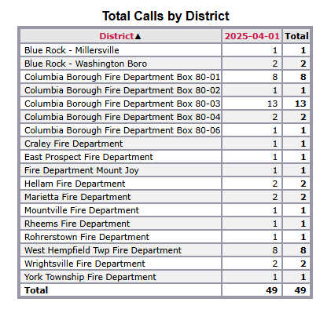

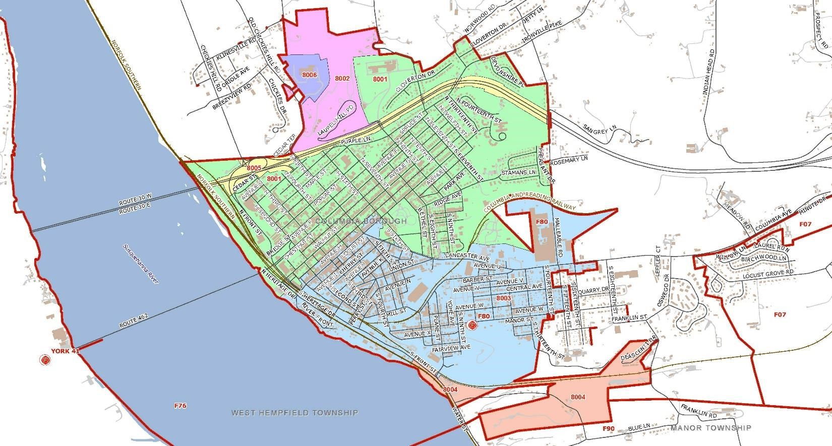
Personnel Name | Jan. | Feb. | March | April | Total | Pct %
Misal, Justin | 43 | 32 | 35 | 31 | 141 | 55%
Stock, Michael | 44 | 33 | 32 | 25 | 134 | 53%
Armold, Michael | 47 | 33 | 29 | 21 | 130 | 51%
Brownsberger, Floyd | 46 | 26 | 29 | 27 | 128 | 50%
Keyser, Kevin | 38 | 29 | 30 | 27 | 124 | 49%
Meisenbach, James | 35 | 31 | 24 | 30 | 120 | 47%
Barninger, Jared | 27 | 24 | 27 | 25 | 103 | 40%
Salcedo, David | 14 | 28 | 21 | 23 | 86 | 34%
Fisher, Jason | 29 | 14 | 23 | 20 | 86 | 34%
Greenya, Alfred | 24 | 16 | 26 | 19 | 85 | 33%
Finegan, Mickenzie | 19 | 21 | 34 | 10 | 84 | 33%
Ryno, Scott | 29 | 18 | 21 | 12 | 80 | 31%
Hershey, David | 36 | 15 | 14 | 9 | 74 | 29%
Finegan, Timothy | 18 | 17 | 29 | 8 | 72 | 28%
Warfel, Robert | 40 | 16 | 11 | 4 | 71 | 28%
Fritz, Mark | 16 | 16 | 18 | 20 | 70 | 27%
Hershey, Denny | 22 | 15 | 13 | 15 | 65 | 25%
Hoffman, Myles | 29 | 9 | 21 | 4 | 63 | 25%
Keyser, Bryan | 12 | 13 | 17 | 16 | 58 | 23%
Fritz, Keith | 14 | 14 | 10 | 19 | 57 | 22%
Bicevskis, Zachary | 13 | 8 | 19 | 12 | 52 | 20%
Fritz, Kyle | 8 | 10 | 18 | 16 | 52 | 20%
Rinkus, Robert | 21 | 9 | 7 | 14 | 51 | 20%
Zercher, Mike | 19 | 13 | 7 | 8 | 47 | 18%
DREWEN, CHRISTOPHER | 25 | 22 | 0 | 0 | 47 | 18%
Fritz, Krystal | 14 | 4 | 12 | 9 | 39 | 15%
Stock, Nathan | 19 | 3 | 12 | 4 | 38 | 15%
Splain, Michael | 17 | 6 | 7 | 7 | 37 | 15%
Hinkle, Ryan | 13 | 11 | 9 | 3 | 36 | 14%
Schoelkoph, Jr., Lester | 16 | 6 | 3 | 2 | 27 | 11%
Drewen, Christopher | 0 | 9 | 13 | 3 | 25 | 10%
Miles, Paul | 10 | 3 | 8 | 2 | 23 | 9%
Cox, James | 11 | 5 | 3 | 3 | 22 | 9%
Falcon, Ken | 10 | 8 | 1 | 0 | 19 | 7%
Annas, Stephen | 5 | 3 | 4 | 6 | 18 | 7%
Boyles, Todd | 7 | 5 | 4 | 2 | 18 | 7%
Montgomery, Sean | 6 | 2 | 4 | 4 | 16 | 6%
Horn, James | 6 | 3 | 2 | 3 | 14 | 5%
Mosteller, Jared | 3 | 5 | 3 | 1 | 12 | 5%
Madaras, Jennifer | 5 | 0 | 4 | 2 | 11 | 4%
Wine, Adrian | 2 | 5 | 2 | 1 | 10 | 4%
Wickenheiser, Seth | 3 | 0 | 4 | 3 | 10 | 4%
Gomez, Lorenzo | 3 | 2 | 1 | 4 | 10 | 4%
Schnaekel, William | 3 | 4 | 2 | 0 | 9 | 4%
Morrison, Hunter | 1 | 4 | 0 | 4 | 9 | 4%
Drewen, Landon | 0 | 3 | 6 | 0 | 9 | 4%
Shaeffer, John | 0 | 0 | 7 | 1 | 8 | 3%
Meyers, William | 2 | 1 | 3 | 1 | 7 | 3%
MENTZER, JR., BRIAN | 7 | 0 | 0 | 0 | 7 | 3%
Mentzer, Brian | 0 | 1 | 3 | 3 | 7 | 3%
Kemmerly, Douglas | 2 | 2 | 0 | 2 | 6 | 2%
Reifsnyder, Robert | 2 | 0 | 4 | 0 | 6 | 2%
Peters, Austin | 1 | 3 | 1 | 1 | 6 | 2%
Manley, Ronald | 0 | 1 | 3 | 2 | 6 | 2%
Schmitt, Eugene | 1 | 1 | 2 | 1 | 5 | 2%
Mosteller, Lacie | 0 | 0 | 4 | 1 | 5 | 2%
Anderson, Jr., Ricky | 2 | 2 | 0 | 0 | 4 | 2%
Warner, Justin | 0 | 0 | 4 | 0 | 4 | 2%
Kline, Derek | 0 | 0 | 4 | 0 | 4 | 2%
Keyser, Brent | 1 | 0 | 0 | 2 | 3 | 1%
Goodman, Jordan | 0 | 3 | 0 | 0 | 3 | 1%
Bowles, Brayden | 0 | 3 | 0 | 0 | 3 | 1%
Fritz, Leslie | 0 | 0 | 1 | 2 | 3 | 1%
Schoelkoph, Lester | 0 | 0 | 0 | 3 | 3 | 1%
WATKINS, MATT | 1 | 0 | 0 | 0 | 1 | 0%
MOSTELLER, LACIE | 0 | 1 | 0 | 0 | 1 | 0%
Jarvis, Jordan | 0 | 1 | 0 | 0 | 1 | 0%
WARNER , JUSTIN | 0 | 0 | 1 | 0 | 1 | 0%
Gorman, Benjamin | 0 | 0 | 1 | 0 | 1 | 0%
Fritz, Lauren | 0 | 0 | 0 | 1 | 1 | 0%

